**First IAM Assignment Solution**

**Problem Statement**

You work to XYZ Corporation to maintain the security of the AWS account and the resources you have been asked to implement a solution that can help easily recognize and monitor the different user.

**You have been asked to**

1. Create a 4 IAM Users name “Dev1”, “Dev2”, “Test1”, and “Test2”.
2. Create Two Groups named “DevTeam” and “OpsTeam”.
3. Add the Dev1 and Dev2 to the Dev Team.
4. Add the Dev1, Test1, and Test2 to the “OpsTeam”.

***Solution starts from the next page:***

**Problem Solution 1:** Create a 4 IAM Users Name “Dev1”, “Dev2”, “Test1”, and “Test2”.

**a. Create the “Dev1” User**

**Step 1: Login** into your **“Amazon AWS account”. Go** to the **"Services"** section & **search** the **"IAM". Click** on the **"IAM" option.**

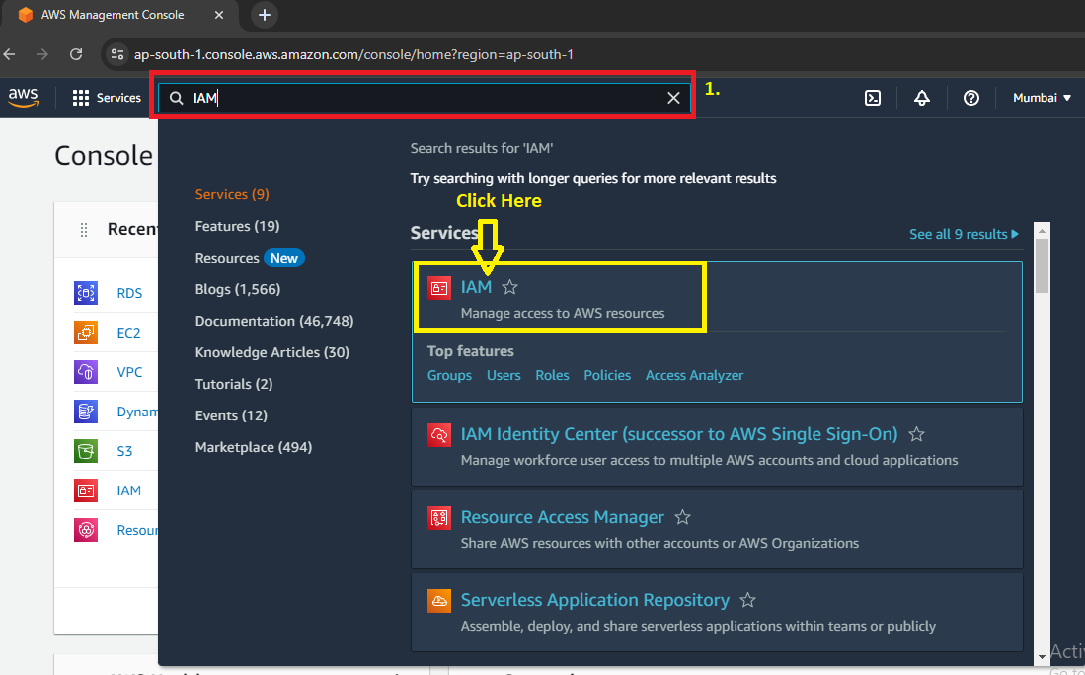

**Step 2: Go** tothe **“Users”.**

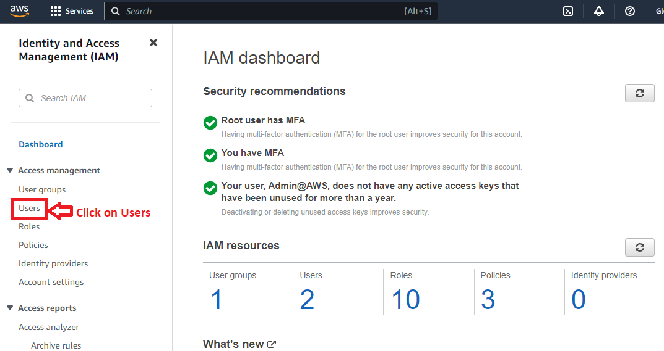

**Step 3: Click** onthe **“Add User”.**

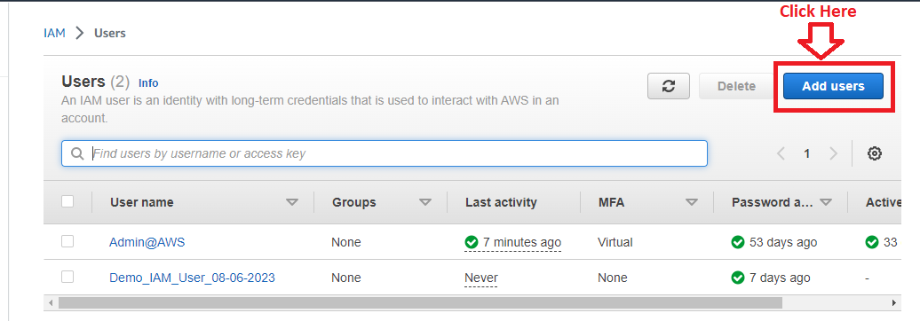

**Step 4:** Inthe **“User name”** section, **put** the **name** asthe **“Dev1”. Tick** the **“Provide user access to the AWS Management Console – optional”** option.

**Choose** the **“I want to create an IAM user”** option.

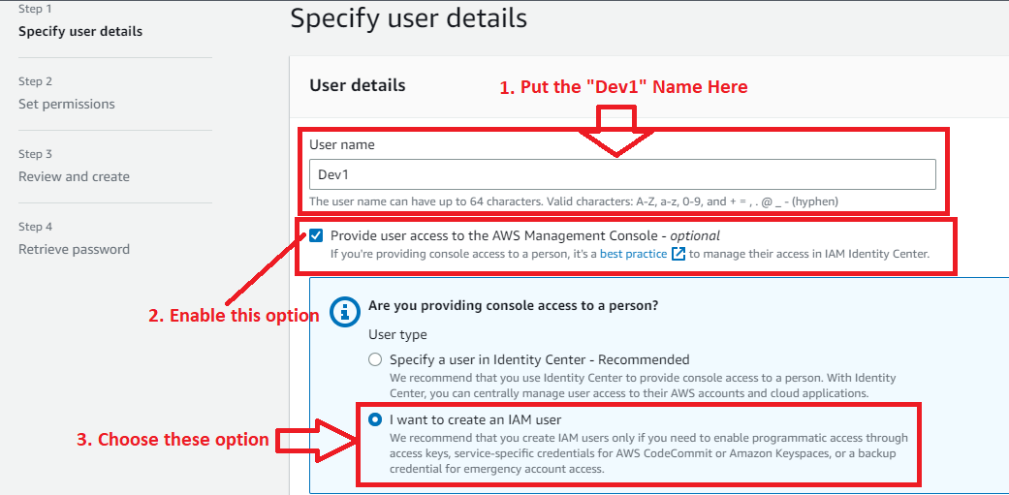

**Step 5: Choose** the **“Custom Password” & enter** your own **password. Click** on the **“Next”**.

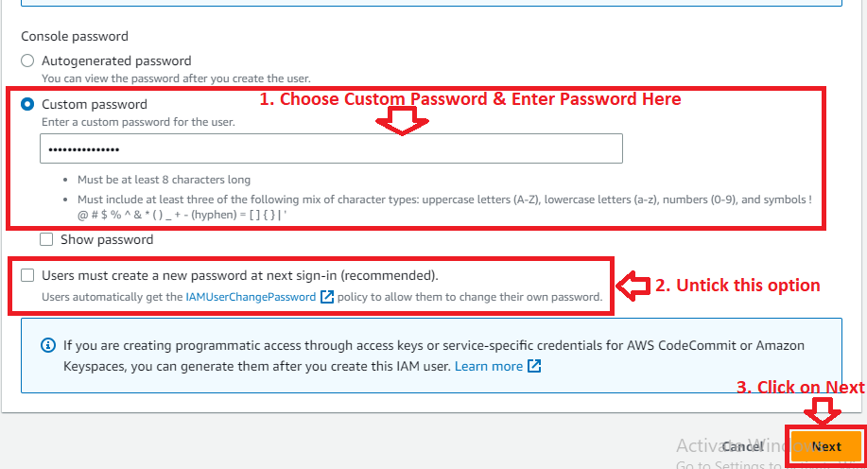

**Step 6:** In the “**Set Permissions”, no need** to **change** here. **Click** on the “**Next”**.

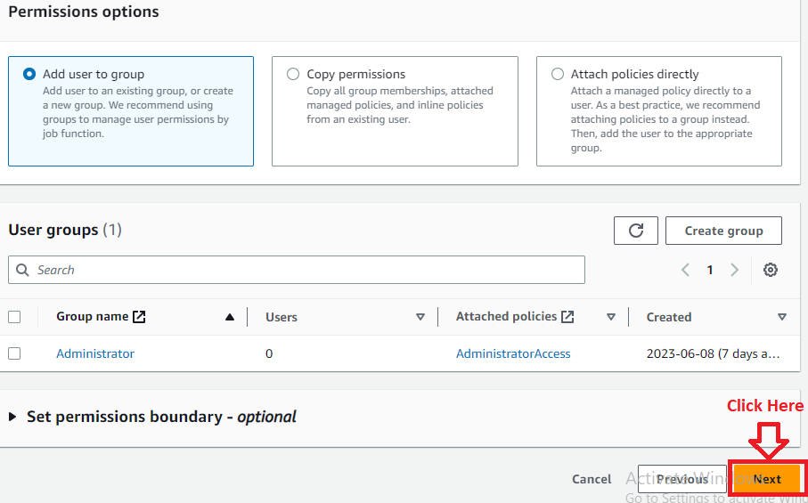

**Step 7:** In the “**Review & Create”** section, **click** on the “**Create user”**.

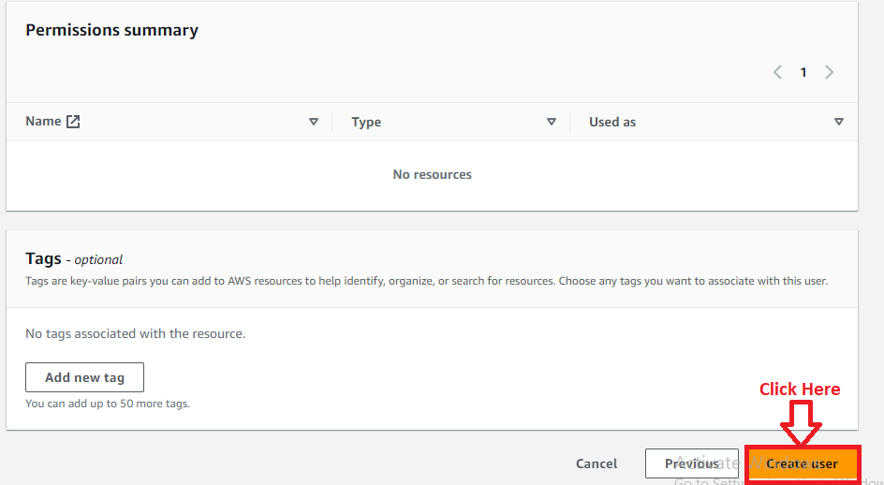

**Step 8: The “user [Dev1]”** will be **successfully created. Here, you** can **copy & paste** the **username & password. Otherwise, you** can **“Download .csv file”.**

**Click** onthe **“Return to users list”.**

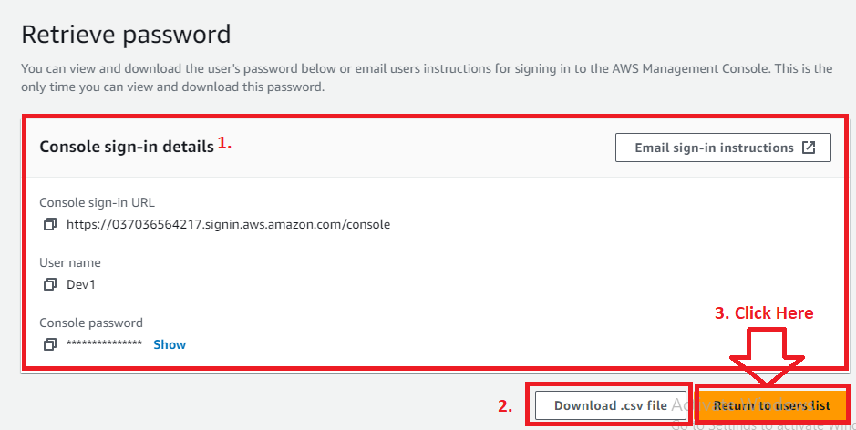

**Step 9: After clicking** onthe **“Return to users list”. If you** don’t **download** the **username & password,** the **below message will be popped up;**

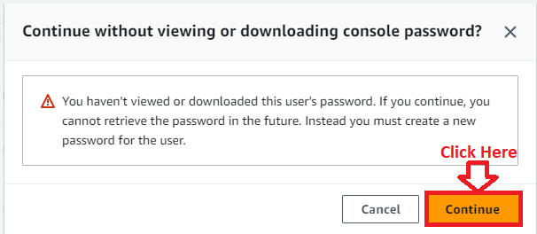

**Click** on the **“Continue”.**

**Step 10: You** can **view** the **created users list** in the **“Users”** section**.**

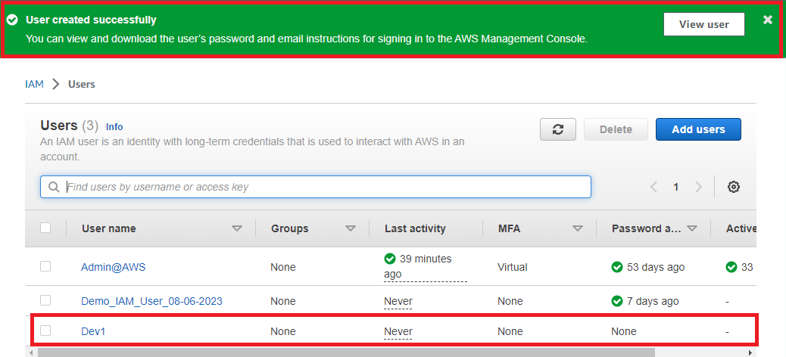

**Step 11: You** can **view** your **created user through clicking** on the **"View user". Your user summary** will be **shown like this;**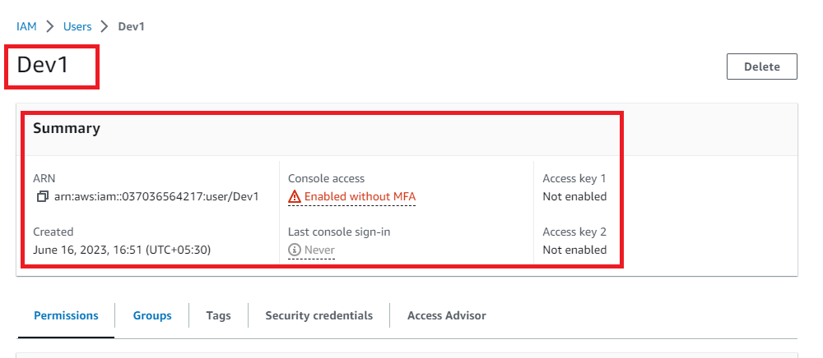

**a. Create the “Dev2” User**

**Step 1: Go** to the **“Users”.**

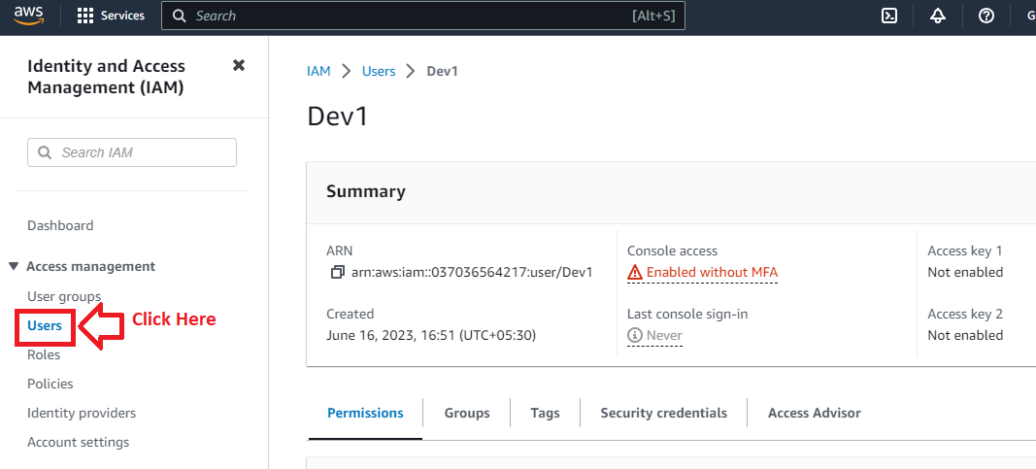

**Step 2: Click** onthe **“Add User”.**



**Step 3:** In **the “User name” option, put** the **name** as the **“Dev2”. Tick** the **“Provide user access to the AWS Management Console – optional”** option.

**Choose** the **“I want to create an IAM user”** option.

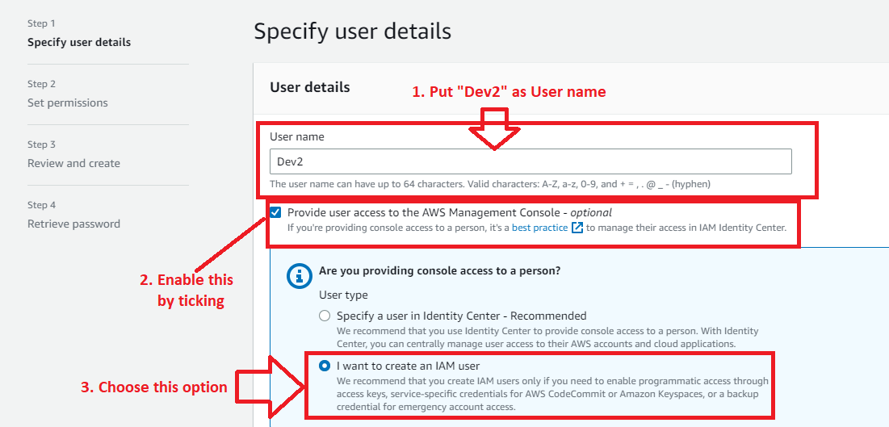

**Step 4: Choose** the **“Custom Password” & enter** your own **password. Click** on the “**Next”**.



**Step 5:** In the “**Set Permissions”**, no need to change. **Click** on the “**Next”**.



**Step 6:** In the “**Review & Create”** section, **click** on the “**Create user”**.



**Step 7: The “user [Dev2]”** will be **successfully created. Here, you** can **copy & paste** the **username & password. Otherwise, you** can **“Download .csv file”.**

**Click** onthe **“Return to users list”.**

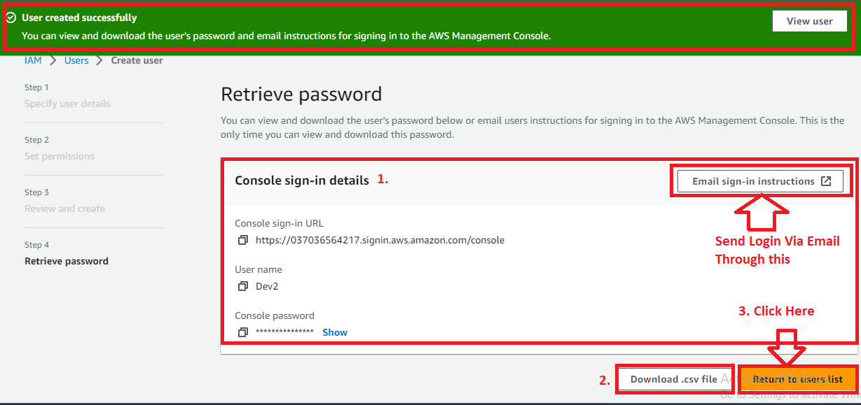

**Step 8: After clicking** onthe **“Return to users list”. If you** don’t **download** the **username & password,** the **below message will be popped up;**



**Click** on the **“Continue”.**

**Step 9: You** can **view created users list** in the **“Users”** section**.**

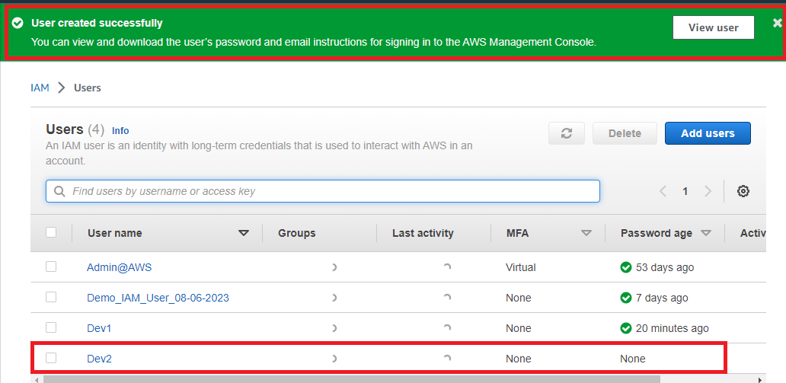

**Step 10: You** can **view** your **created user through clicking** on the **"View user". Your user summary** will be **shown like this;**

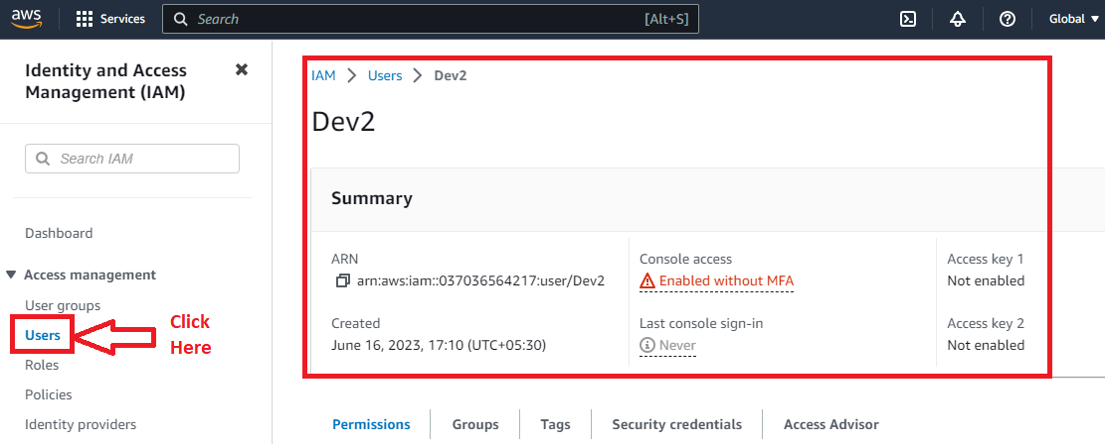

**c. Create the “Test1” User**

**Step 1: Go** tothe **“Users”.**



**Step 2: Click** onthe **“Add User”.**



**Step 3:** In the **“User name”, put** the **name** asthe **“Test1”. Tick** the **“Provide user access to the AWS Management Console – optional”** option.

**Choose** the **“I want to create an IAM user”** option.

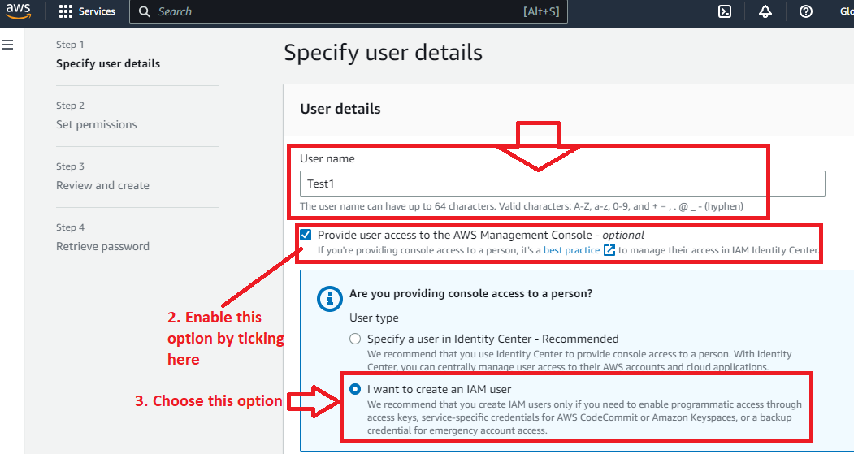

**Step 4: Choose** the **“Custom Password” & Enter** your own **password. Click** on the “**Next”**.

**"**

**Step 5:** In the “**Set Permissions” option**, no need to change. **Click** on the “**Next”**.



**Step 6:** In the “**Review & Create” option**, **click** on the “**Create user”**.



**Step 7: The “user (Test1)”** will be **successfully created. Here, you** can **copy & paste** the **username & password. Otherwise, you** can **“Download .csv file”.**

**Click** on **“Return to users list”.**

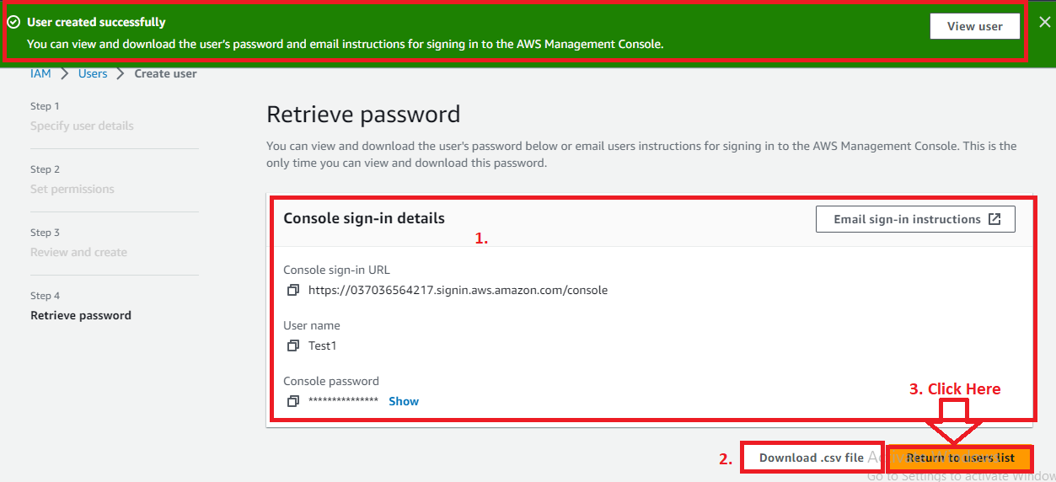

**Step 8: After clicking** onthe **“Return to users list”. If you** don’t **download** the **username & password,** the **below message will be popped up;**



**Click** onthe **“Continue”.**

**Step 9: You** can **view** the **created users list** in the **“Users”** section**.**

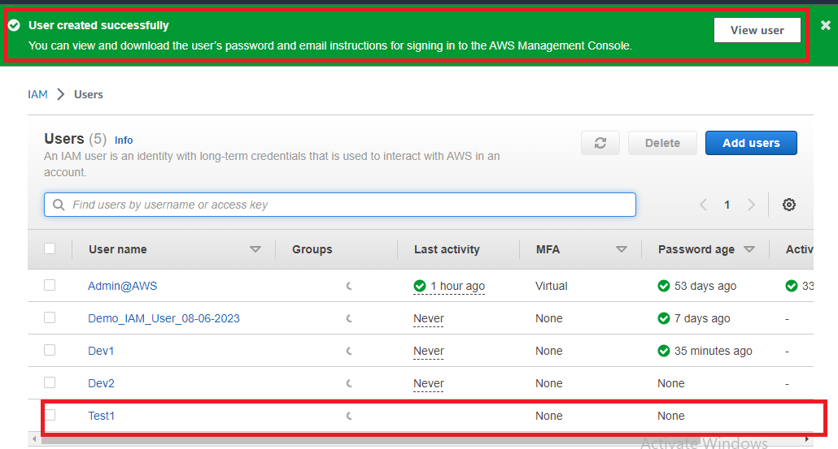

**Step 10: You** can **view** your **created user through clicking** on the **"View user". Your user summary** will be **shown like this;**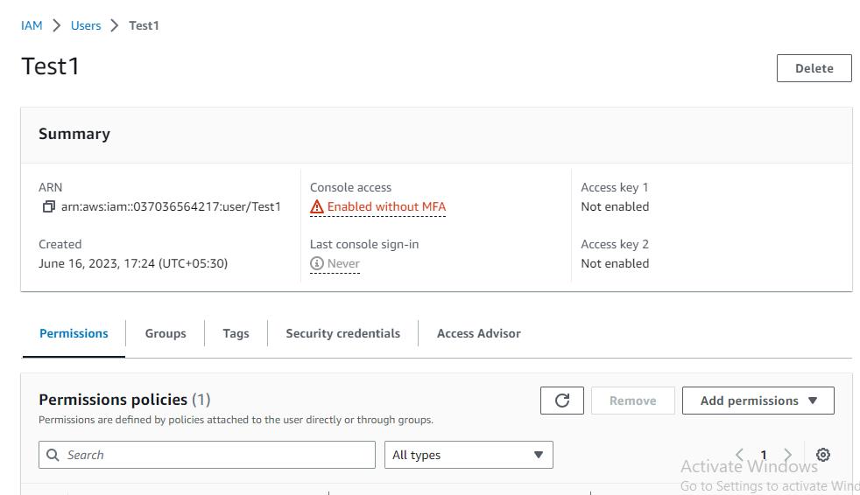

**d. Create the “Test2” User**

**Step 1: Go** tothe **“Users”.**



**Step 2: Click** onthe **“Add User”.**



**Step 3: In** the **“Username”, put** the **name** asthe **“Test1”. Tick** the **“Provide user access to the AWS Management Console – optional”** option.

**Choose** the **“I want to create an IAM user”** option.

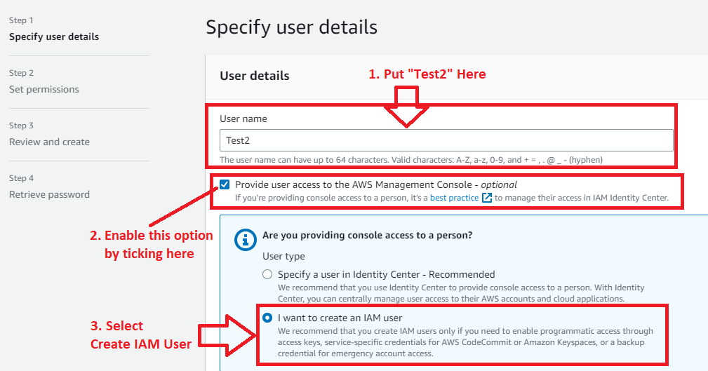

**Step 4: Choose** the **“Custom Password” & enter** your own **password. Click** on the “**Next”**.



**Step 5:** In the “**Set Permissions”**, no need to change. **Click** on the “**Next”**.



**Step 6:** **In** the “**Review & Create”** option, **click** on the “**Create user”**.



**Step 7: The “user [Test2]”** will be **successfully created. Here, you** can **copy & paste** the **username & password. Otherwise, you** can **“Download .csv file”.**

**Click** onthe **“Return to users list”.**

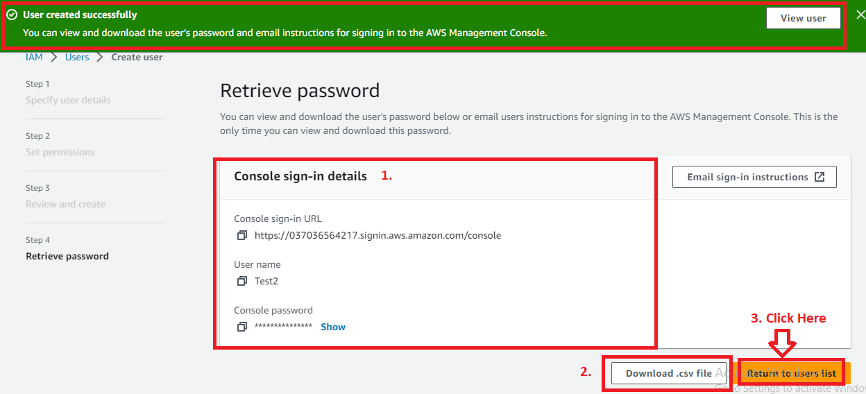

**Step 8: After clicking** onthe **“Return to users list”. If you** don’t **download** the **username & password,** the **below message** will be **popped up;**



**Click** onthe **“Continue”.**

**Step 9: You** can **view** the **created users list** in the **“Users”** section**. You** can **view** your **created user, click** on **the “View user”. The user summary** will be **shown like this:**

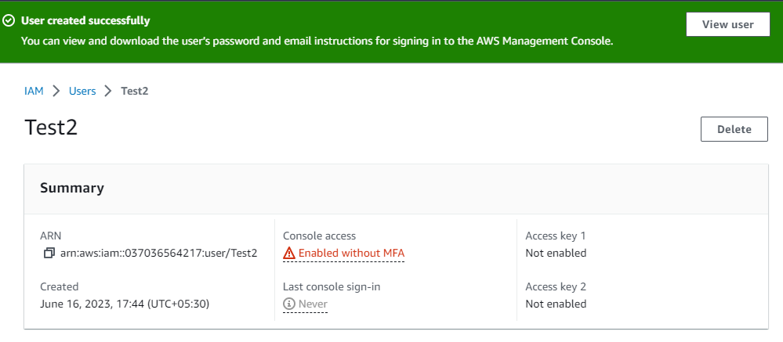

**Problem Solution 2:** Create Two Groups named “DevTeam” and “OpsTeam”

**a. Create the “Dev Team” Group**

**Step 1: Click** on the **“User Groups”.**

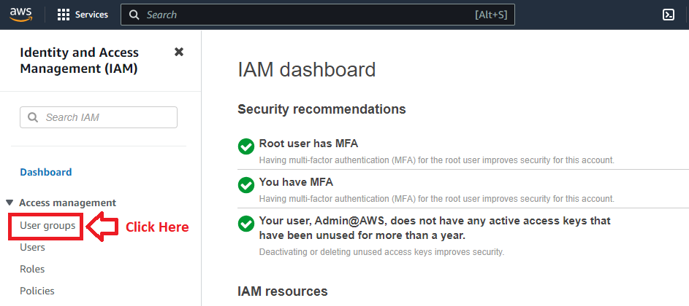

**Step 2: Click** on the “**Create Group’**.

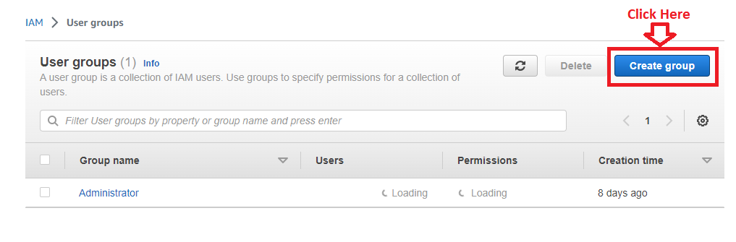

**Step 3: Put** the **“DevTeam”** in **the “User group name”** option.

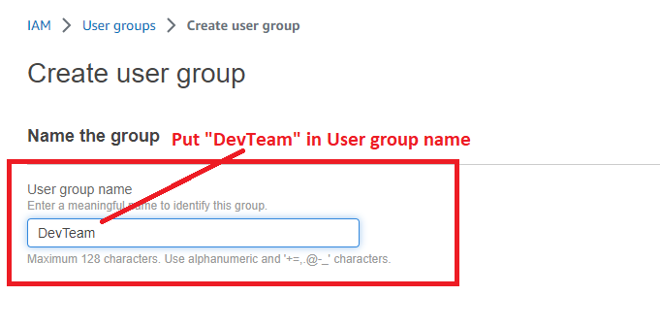

**Step 4: We** will **leave** the **add users** & **attach policy options** without **selection** for **now. Click** onthe **“Create Group”.**

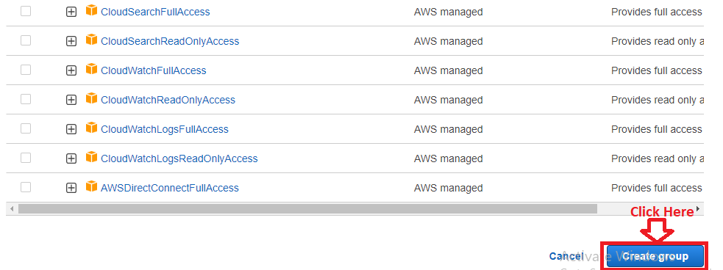

**Step 5: The “DevTeam” user group** will be **successfully created.**

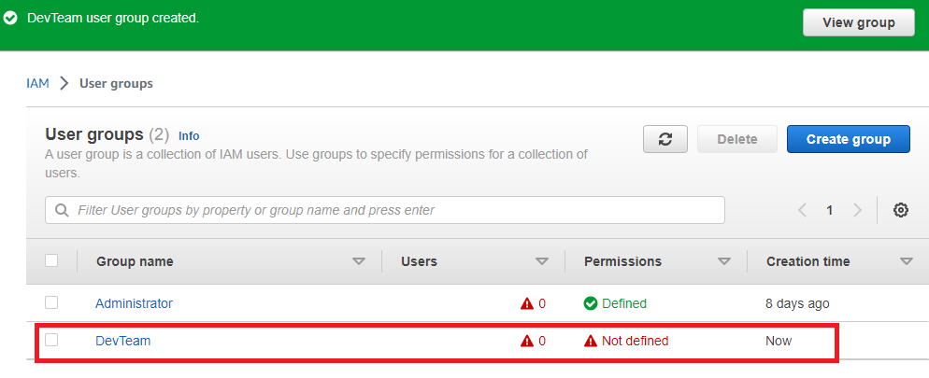

**b. Create the “OpsTeam” Group**

**Step 1: Click** on **the “Create group”.**



**Step 2:** **Put** the **“OpsTeam”** in the “**User group name”** option.

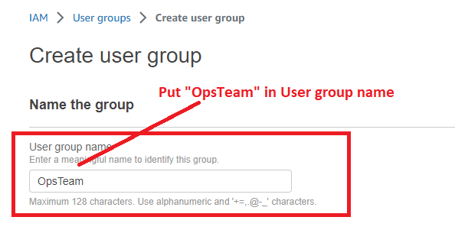

**Step 3: Click** on the **“Create group”**.



**Step 4: The “OpsTeam” user group** will be **successfully created**.

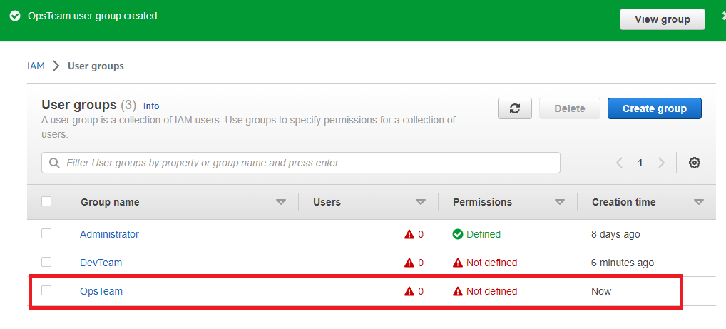

**Problem Solution 3:** Add Dev1 and Dev2 to the “DevTeam”

***Add Dev1 and Dev2 to “DevTeam” through User Groups***

**Step 1: Click** onthe **“DevTeam”.**

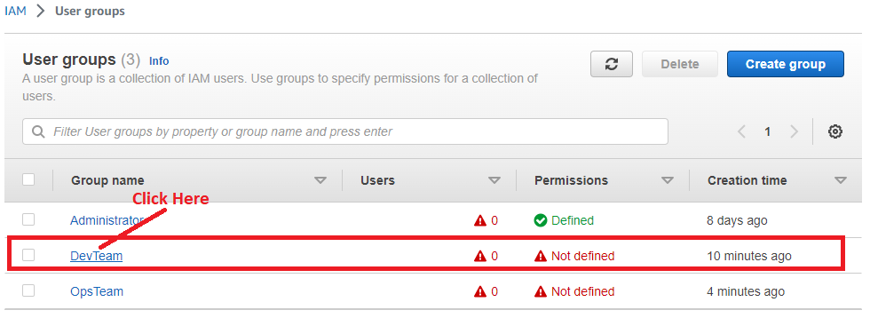

**Step 2: Go** tothe **“Users”** & **Click** onthe **“Add Users”.**

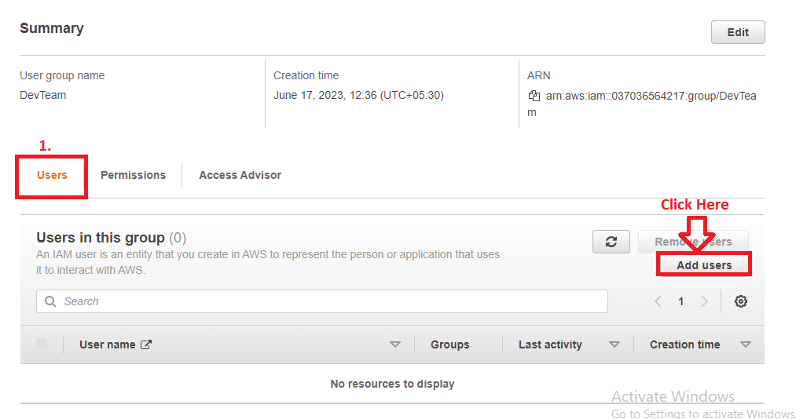

**Step 3: Select** the **“Dev1”** & **“Dev2”** inthe **“Add Users” to the “DevTeam”. Click** on the “**Add Users**”.

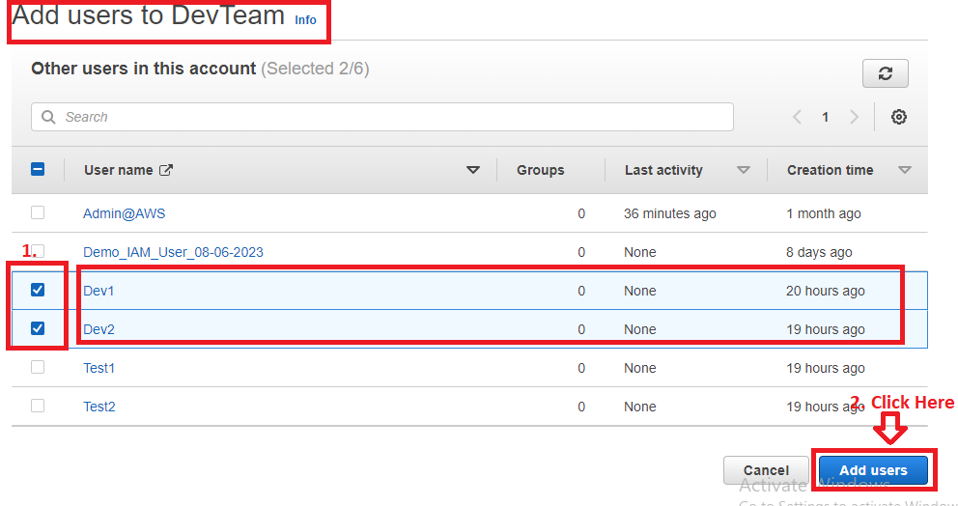

**Step 4: The users (“Dev1”** & **“Dev2”)** will be **successfully added** inthe **“DevTeam”.**

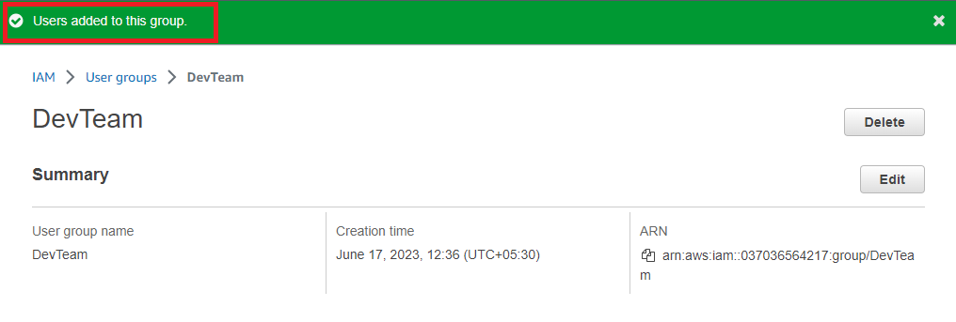

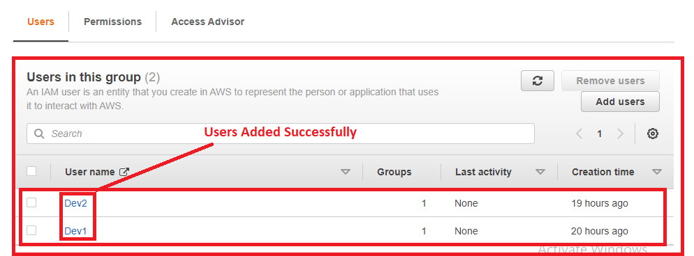

**Problem Solution 4:** Add the Dev1, Test1, and Test2 to the OpsTeam.

***Add the Dev1, Test1, and Test2 to the “OpsTeam” Through Users (Alternative Way)***

**a. Add the Dev1 to the “OpsTeam”**

**Step 1: Click** on the **“Users”**.

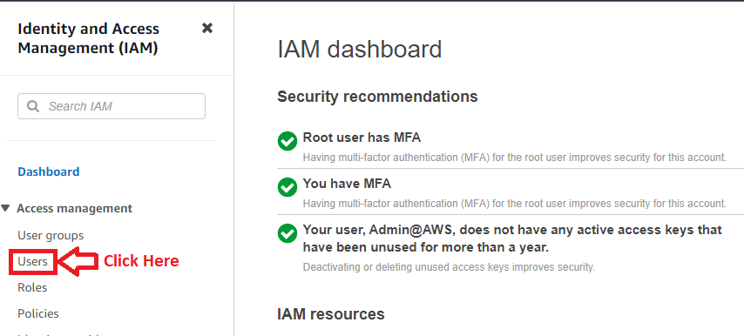

**Step 2: Click** on the **“Dev1”**.

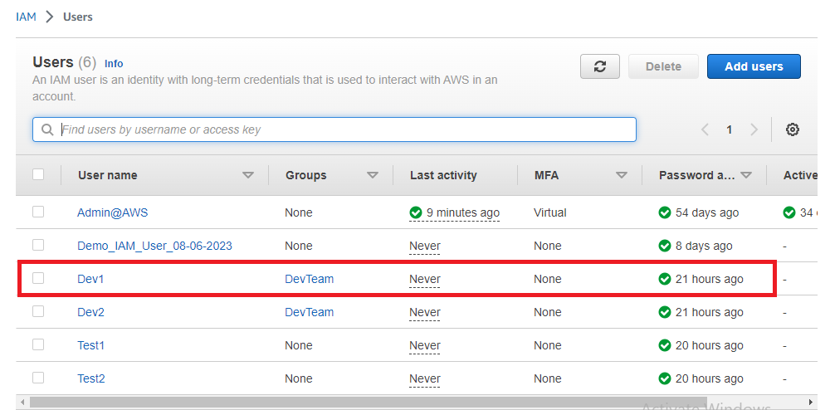

**Step 3: Click** on the **“Groups”**.

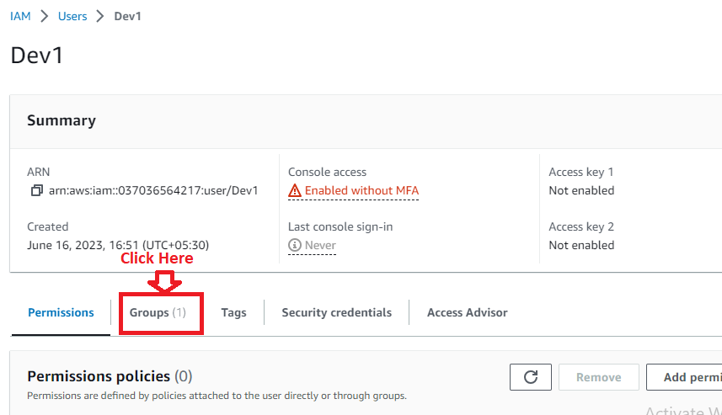

**Step 4: Click** onthe **“Add user to groups”.**

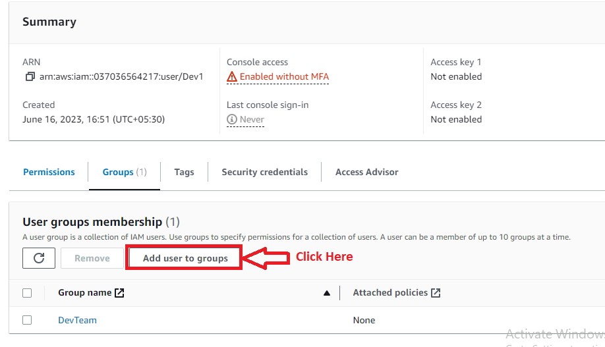

**Step 5: Choose** the **“OpsTeam” option. Click** onthe **“Add user to group(s)”.**

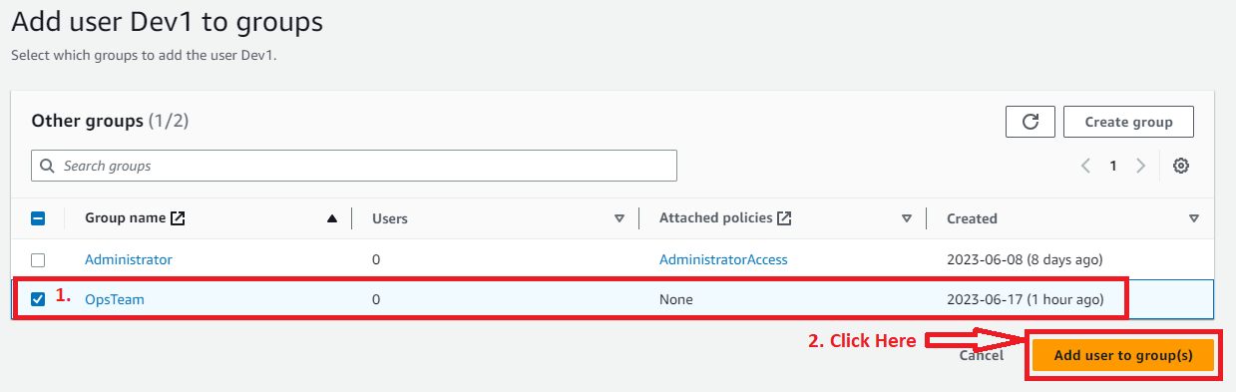

**Step 6: The** user **“Dev1”** will be **successfully added** to the **“OpsTeam”.**

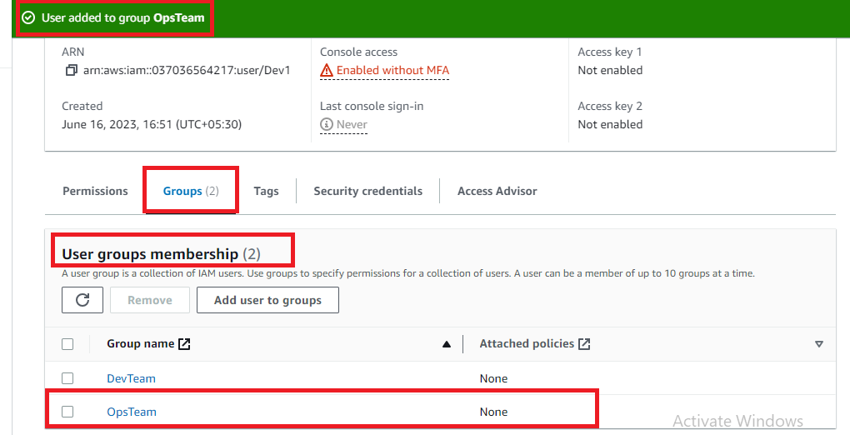

**b. Add Test1 to the “OpsTeam”**

**Step 1: Click** on the **“Users”**.

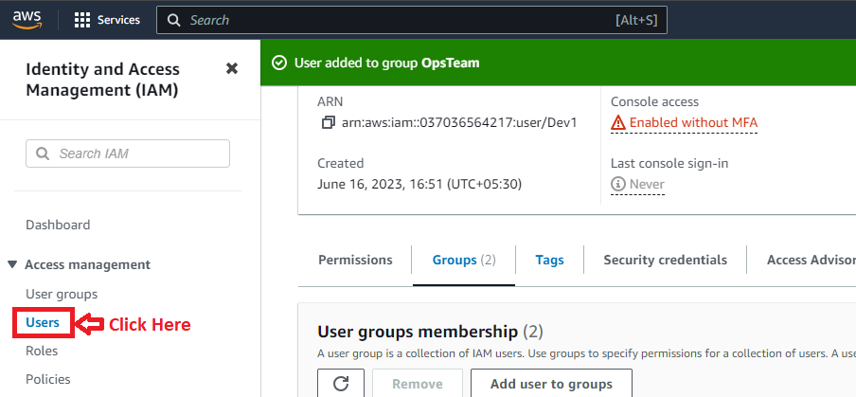

**Step 2: Click** on the **“Test1”**.

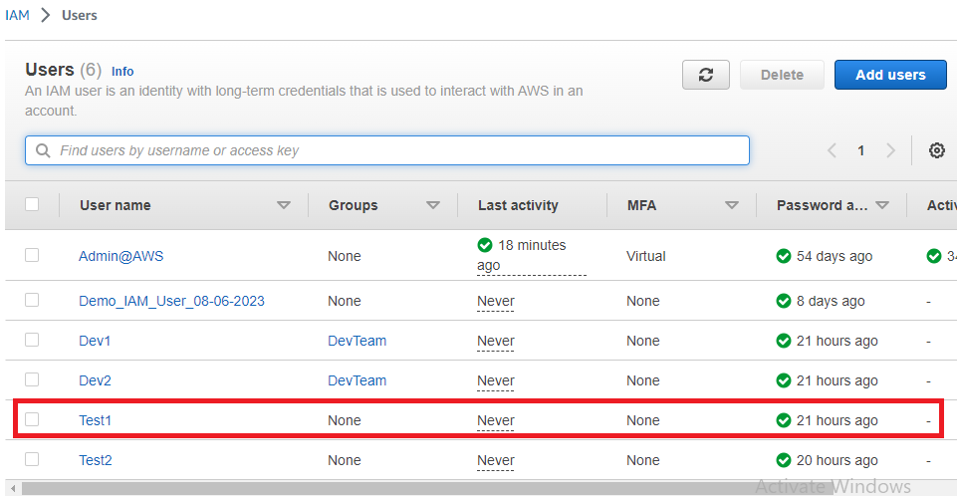

**Step 3: Click** on the **“Groups”**.

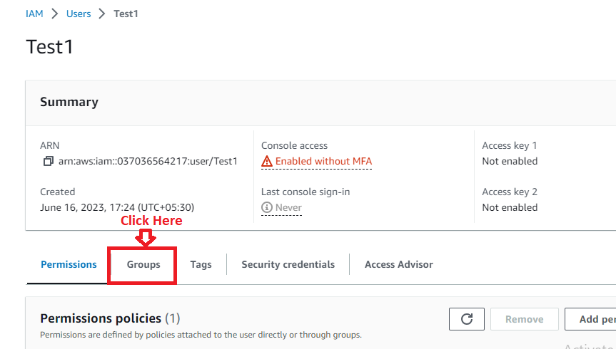

**Step 4: Click** onthe **“Add user to groups”.**

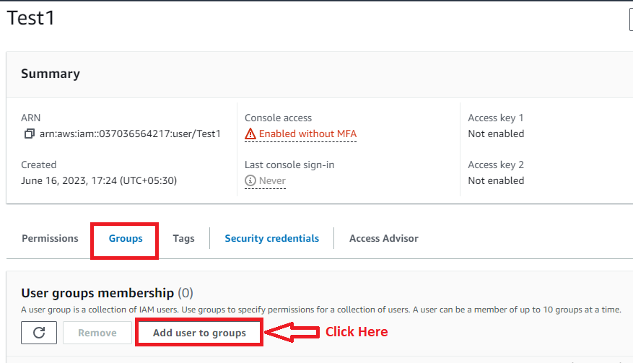

**Step 5: Choose** the **“OpsTeam” option. Click** on the **“Add user to group(s)”.**

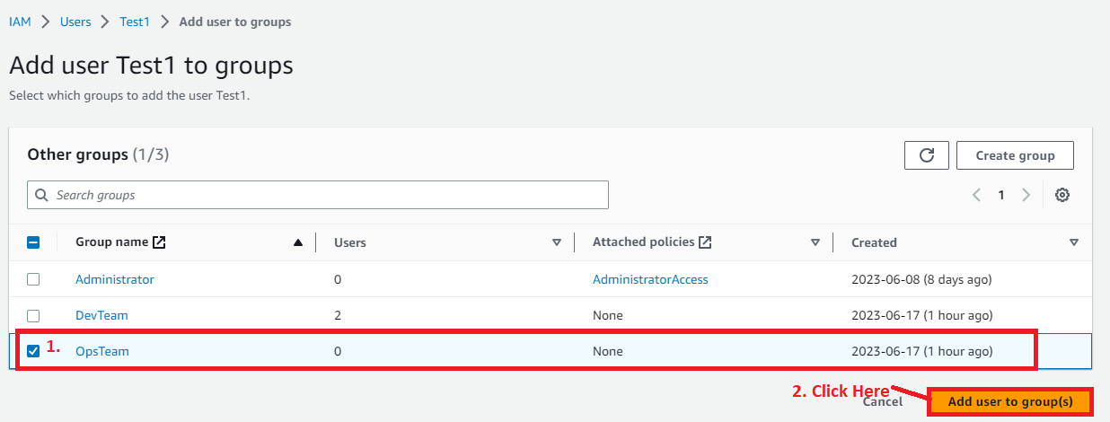

**Step 6: The** user **“Test1”** will be **successfully added** to the **“OpsTeam”.**

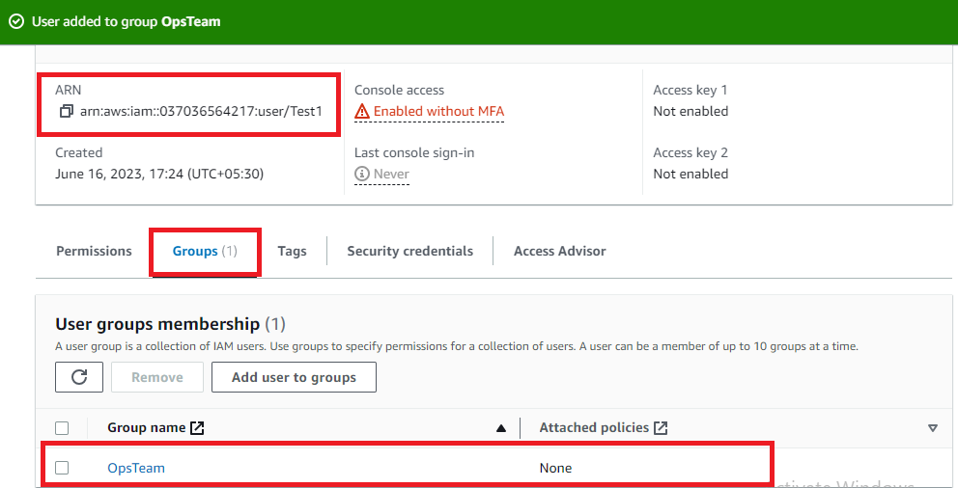

**c. Add the Test2 to the “OpsTeam”**

**Step 1: Click** on the **“Users”**.



**Step 2: Click** on the **“Test2”**.

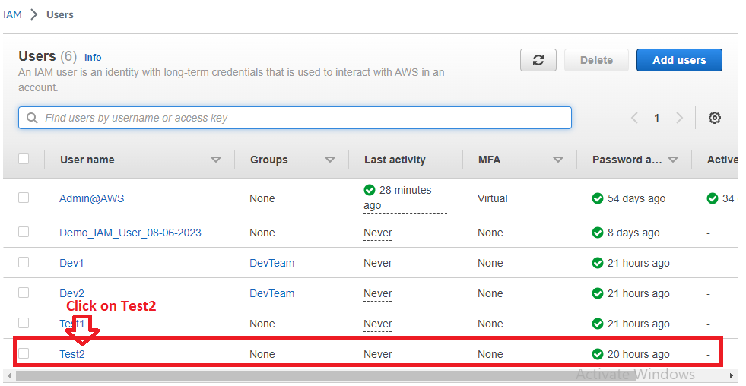

**Step 3: Click** on the **“Groups”**.

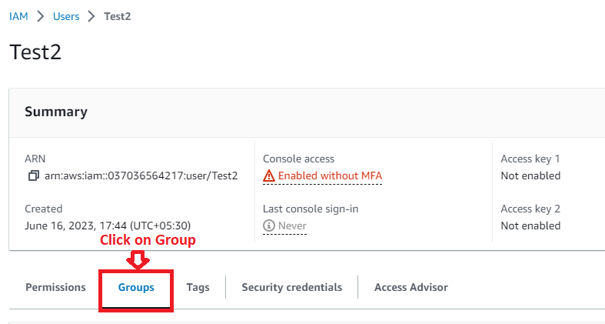

**Step 4: Click** onthe **“Add user to groups”.**

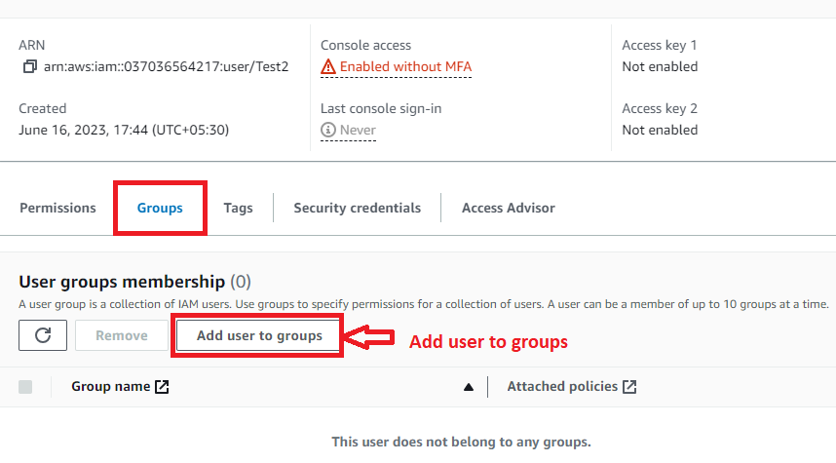

**Step 5: Choose** the **“OpsTeam” option. Click** onthe **“Add user to group(s)”.**

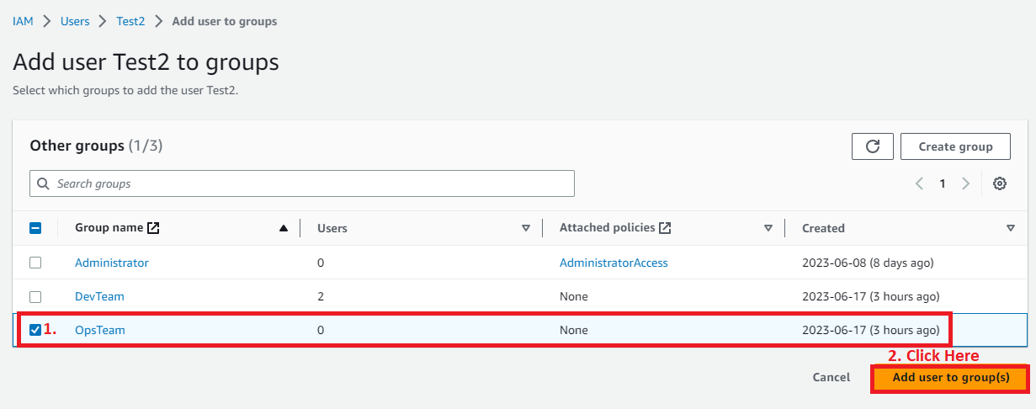

**Step 6: The** user **“Test2”** will be **successfully added** to the **“OpsTeam”.**

